Build a slide presentation (PowerPoint preferred) of the hypothetical health promotion plan you developed in the first assessment. Then, implement your health promotion plan by conducting a hypothetical face-to-face educational session addressing the health concern and health goals of your selected group. How would you set goals for the session, evaluate session outcomes, and suggest possible revisions to improve future sessions?
As you begin to prepare this assessment, you are encouraged to complete the Vila Health: Conducting an Effective Educational Session activity. The information gained from completing this activity will help you succeed with the assessment as you consider key issues in conducting an effective educational session for a selected audience. Completing activities is also a way to demonstrate engagement.
Note: All assignments in the course are based upon hypothetical individuals or groups.

Professional Context
Health education is any combination of learning experiences designed to help community individuals, families, and aggregates improve their health by increasing knowledge or influencing attitudes (WHO, 2018). Education is key to health promotion, disease prevention, and disaster preparedness. The health indicator framework identified in Healthy People 2020 helps motivate action in such areas as health service access, clinical preventive services, environmental quality, injury or violence, maternal, infant and child health, mental health, nutrition, substance abuse, and tobacco use.
Nurses provide accurate evidence-based information and education in various formal and informal settings. They draw upon evidence-based practice to provide health promotion and disease prevention activities to create social and physical environments conducive to improving and maintaining community health. When provided with the tools to be successful, people demonstrate lifestyle changes (self-care) that promote health and help reduce readmissions. They are better able to tolerate stressors, including environmental changes, and enjoy a better quality of life. In times of crisis, a resilient community is a safer community (ODPHP, n.d.; Flanders, 2018).
This assessment provides an opportunity for you to apply teaching and learning concepts to the presentation of a health promotion plan.

Demonstration of Proficiency
By successfully completing this assessment, you will demonstrate your proficiency in the following course competencies and assessment criteria:
- Competency 3: Evaluate health policies, based on their ability to achieve desired outcomes.
  - Evaluate educational session outcomes in terms of progress made toward Healthy People 2020 goals and leading health indicators.
- Competency 4: Integrate principles of social justice in community health interventions.
  - Evaluate educational session outcomes and the attainment of agreed-upon health goals in collaboration with participants.
- Competency 5: Apply professional, scholarly communication strategies to lead health promotion and improve population health.
  - Present a health promotion plan to an individual or group within a community.

References
U.S. Department of Health and Human Services, Office of Disease Prevention and Health Promotion (ODPHP). (n.d.). Healthy People 2020. Retrieved from https://www.healthypeople.gov/
Flanders, S. A. (2018). Effective patient education: Evidence and common sense. Medsurg Nursing, 27(1), 55–58.
Note: This is the second part of a two-part assessment. You must complete Assessment 1 before completing this assessment.

Preparation
This assessment builds upon Assessment 1 where you developed a health promotion plan for a hypothetical individual or group based on a topic list. You will resume the role of a community nurse tasked with addressing the specific health concern in your community. This time, you will present, via educational outreach, the hypothetical health promotion plan you developed in Assessment 1 to your chosen individual or group. In this hypothetical scenario, the presentation would be live and face-to-face. You must determine an effective teaching strategy, communicate the plan with professionalism and cultural sensitivity, obtain input on the value of the plan to the individual or group, and revise the plan, as applicable, to improve future educational sessions. To engage your audience, you decide to develop a PowerPoint presentation with voice-over and speaker notes to communicate your plan.
Remember that your first assessment (Assessment 1) MUST be satisfactorily completed to initiate this assessment (Assessment 4).
Please review the assessment scoring guide for more information.
To prepare for the assessment, you are encouraged to complete the Vila Health: Conducting an Effective Educational Session simulation. You may also wish to review the health promotion plan presentation assessment and scoring guide to ensure that you understand all requirements.
Note: Remember that you can submit all, or a portion of, your draft plan to Smarthinking Tutoring for feedback before you submit the final version for this assessment. If you plan on using this free service, be mindful of the turnaround time of 24–48 hours for receiving feedback.

Instructions
Complete the following:
- Hypothesize what a face-to-face educational session would consist of, addressing the health concern and health goals of your selected community member, friend, family member, or group. Imagine collaborating with the hypothetical participant(s) in setting goals for the session, evaluating session outcomes, and suggesting possible revisions to improve future sessions.
- Prepare a PowerPoint presentation, which should include audio-recorded voice over, of the health promotion plan you developed in Assessment 1, with detailed speaker's notes that include your evaluation of session outcomes. Speaker notes should reflect what you would actually say were you to conduct the presentation with an actual audience.
As you begin to prepare this assessment, you are encouraged to complete the Vila Health: Conducting an Effective Educational Session activity. The information gained from completing this activity will help you succeed with the assessment as you consider key issues in conducting an effective educational session for a selected audience. Completing activities is also a way to demonstrate engagement.

PRESENTATION FORMAT AND LENGTH
You may use Microsoft PowerPoint (preferred) or other suitable presentation software to create your presentation. If you elect to use an application other than PowerPoint, check with your faculty to avoid potential file compatibility issues.
The number of content slides in your presentation is dictated by nature and scope of your health promotion plan. Be sure to include title and references slides per the following:
- Title slide:
  - Health promotion plan title.
  - Your name.
  - Date.
  - Course number and title.
- References (at the end of your presentation).
  - Be sure to apply correct APA formatting to your references.
The following resources will help you create and deliver an effective presentation:
- Record a Slide Show With Narration and Slide Timings.
  - This Microsoft article provides steps for recording slide shows in different versions of PowerPoint, including steps for Windows, Mac, and online.
- Microsoft Office Software.
  - This Campus page includes tip sheets and tutorials for Microsoft PowerPoint.
- PowerPoint Presentations Library Guide.
  - This library guide provides links to PowerPoint and other presentation software resources.
- SoNHS Professional Presentation Guidelines [PPTX].
  - This presentation, designed especially for the School of Nursing and Health Sciences, offers valuable tips and links, and is itself a PowerPoint template that can be used to create a presentation.

SUPPORTING EVIDENCE
Support your plan with at least three professional or scholarly references, published within the last 5 years, which may include peer-reviewed articles, course study resources, and Healthy People 2020 resources.

GRADED REQUIREMENTS
The requirements outlined below correspond to the grading criteria in the assessment scoring guide, so be sure to address each point. Read the performance-level descriptions for each criterion to see how your work will be assessed.
- Present your health promotion plan to your hypothetical audience.
  - Tailor the presentation to the needs of your hypothetical audience.
  - Adhere to scholarly and disciplinary writing standards and APA formatting requirements.
- Evaluate educational session outcomes and the attainment of agreed-upon health goals in collaboration with participants.
  - Which aspects of the session would you change?
  - How might those changes improve future outcomes?
- Evaluate educational session outcomes in terms of progress made toward Healthy People 2020 goals and leading health indicators.
  - What changes would you recommend to better align the session with Healthy People 2020 goals and leading health indicators?

Additional Requirements
Before submitting your assessment, proofread your presentation slides and speaker's notes to minimize errors that could distract readers and make it difficult for them to focus on the substance of your presentation.
Portfolio Prompt: Remember to save the assessment to your ePortfolio so that you may refer to it as you complete the final capstone course.

********

Conducting an Effective Educational Session

Introduction
Complete this activity to address key issues in designing and implementing an effective health promotion plan for a selected audience.


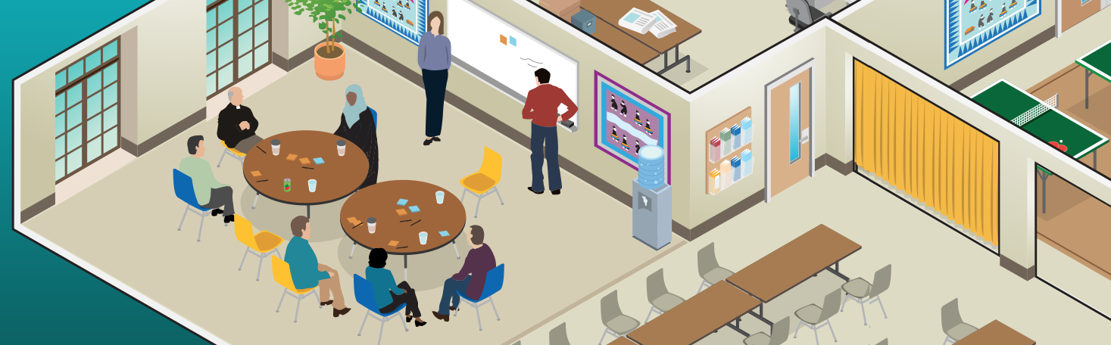
You are visiting a local community center to support your friend and fellow nurse on his first day at work. The center is the first in the area dedicated to the homeless—primarily Latino—population in the neighborhood, who speak English as a second language. The community started a community garden to help combat food insecurity in the area.
John takes you on a tour of the facility. He is excited to have you listen to an educational session presented by June. The goal of this session is to teach the participants how to prepare healthy foods using the vegetables from the garden. A local co-op donated beef, a protein source.
As June spoke with the participants about what constitutes a balanced meal, she cleans the potatoes and carrots. She explains to them in English that the skins provide nutrients, so they should not be peeled. As she continued with her lesson, you overheard some participants saying in Spanish that “Only pigs eat vegetable skins. She is trying to feed us slop! She thinks that we are pigs. We don’t eat slop!” Many participants refused to eat the stew and left shaking their heads. A few who remained told her that they had no access to a stove, because they were living on the streets.
Answer the following questions based on this scenario:

Which Healthy People 2020 health Indicators apply to this situation?
- Nutrition
- Oral Health
- Sexual Health
- Substance Abuse
- Obesity
- Educational and Community-Based Programs
- Older Adults
This question has not yet been answered.

How might this session have been improved?
This question has not yet been answered.
Some potential ways to improve this session would have been to:
- Interview participants to determine learning needs and establish mutual goals.
- Avoid assuming that the participants could afford to purchase and prepare the meals. Homeless individuals may have access to the community garden, but may have no access to protein sources or a place to prepare a meal in the way modeled during the session.
- Learn as much as possible about the local Latino population and culture by consulting appropriate resources and by talking with participants at the center.
- Interview participants to identify cultural norms and beliefs.
- Provide the assistance of a Spanish-speaking interpreter.

